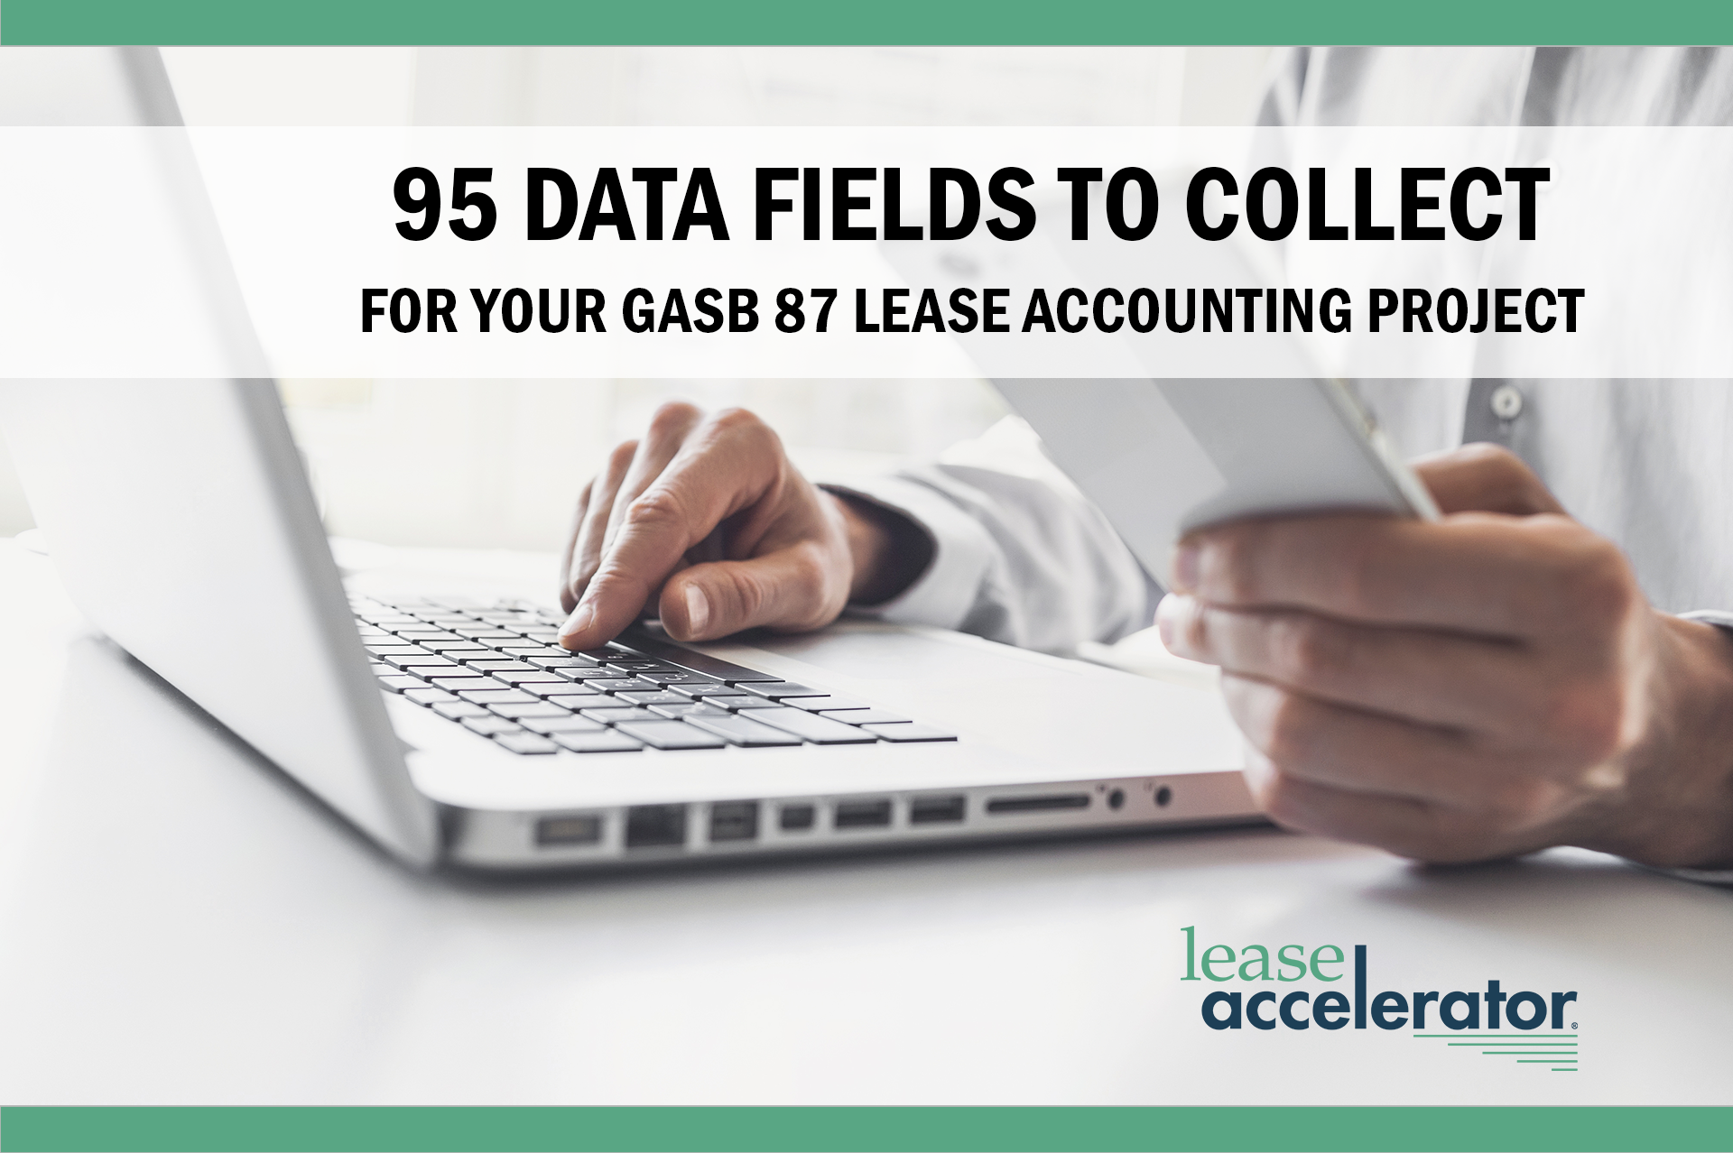

LEASE ACCOUNTING – GASB 87

95 DATA FIELDS TO COLLECT FROM YOUR LEASES

Starting the data collection process can be overwhelming for many companies. That’s why, here at LeaseAccelerator, we’ve outlined 95 of the data fields you should collect from your leases. As you’re going through the document, you may want to fill out where you can find each data field in the last column. Also note that some of these fields are required for all leases, but others are only required for certain lease types and some are just strongly recommended.

PAYMENTS:
The following data fields impact lease payments. Changes to payments will impact how you account for your leases.

Number | Short Description | Description | Where To Find It
1. | Commencement/ Start Date | The commencement date is when the duration of the lease starts and your payment schedule begins.
2. | Quantity of Units  (Equipment) | The number of units of each type of equipment asset that are being leased.
3. | Floor Space Leased  (Real Estate) | For real estate leases you will need to capture the amount of total space leased and the amount of leased space that is actually usable. Floor space leased directly impacts accounting for utility-based leases, where payments are based off of your utilization of the building, as well as your utilization of utilities and services.
4. | Original Cost  (Equipment) | The original equipment cost that is being financed in the lease. The cost can also help you negotiate end-of-term buyout or renewal pricing.
5. | Payment Currency | The transactional currency used to make the lease payments. The payment currency is used to determine the foreign exchange rate, which you will use to calculate the currency you use for accounting.
6. | Base Rent Payment | The amount of base rent paid to the lessor each period. This can be derived from the lease rate factor that shows what fraction of the original cost must be paid each period.
7. | Payment Frequency | How often and at what rate lease payments are made. It could be monthly, quarterly, annually, or biannually.
8. | Payment Duration | The number of payments made during the lifecycle of the lease (between the commencement date and the end of term).
9-10. | One-Time or Recurring  - Payments  - Expense | Payment adjustments and expenses can be either one-time (in one period) or recurring (for all future periods).
11-12. | Usage-Based Payments  - Unit of Measurement  - Price-Per-Unit | In some leases, rent varies based on the usage of that asset. If that’s the case, you will need to determine the underlying unit of measurement upon which the rent formula is based. Examples might include mileage, per unit of production, or the duration of time used. Also consider the price-per-unit specified in the lease.
13-17. | Index-Based Payments  - Rent Calculation  - Index Rate  - Benchmark Date  - Spread Over Index  - Adjustment Frequency | In some leases, part or all of the rent payment will vary based upon a public index such as CPI or LIBOR. If that’s the case, you will need the index that the floating payment is based upon as well as the benchmark date for the index rate. Also, you will need the spread over index that is added or subtracted to the public index in order to determine the actual rate. You will also need to know the adjustment frequency - monthly, quarterly or annually.
18-19. | Performance-Based Payments  - Rent Calculation  - Adjustment Frequency | In some leases, part or all of the rent payment will vary based upon a performance metric. For example, some retail space rent calculations are based upon the tenant’s annual sales. If this is the case, determine the underlying formula used to calculate the rent as well as the adjustment frequency.
20. | Rent Escalation Cap | This is the maximum amount a rental payment can increase. It’s used for leases with floating rates based on index, usage, or performance.
21-23. | Step Payments  - Payment Numbers  - Payment Amounts  - Adjustment Frequency | Step payments are uneven payments during the term. If this is the case for your lease, you will need to determine the different payment schedules, the payment number that each step begins, how many payments the step continues, and the amounts and frequencies for each step.
24. | Repayment Mode | Payments could be made in advance or in arrears. Determine which repayment mode is specified on your lease.
25. | Incremental  Borrowing Rate | This is the rate your finance or treasury organization uses as the discount rate to calculate the present value of your lease payments.
26-29. | Interim Rent  - Payment  - Lease Rate Factor  - Index  - Spread Over Index | Interim rent is the payment for use of real estate or equipment between the acceptance of the lease and the lease start date. If there is interim rent, determine if it is based on a fixed or floating rate, the amount of the interim rent payment, and the lease rate factor. If it’s based on a floating rate, determine the benchmark the rent is tied to. You will also need the interim rate spread, which is added or subtracted to the interest rate benchmark to arrive at the final interim rent.
30. | Lease Incentives | There are sometimes incentives associated with a lease. These might include fees being paid to you as a lessee or being paid on your behalf. Record the timing and amount of these payments.

EXPENSES:
The following data fields impact lease expenses. Certain expenses may impact your lease accounting.

Number | Short Description | Description | Where To Find It
31. | Asset Retirement Obligations | Some leases may include asset retirement obligations or end-of-lease expenses. For real estate, the expenses could be for restoring the property to its original condition. For equipment, the expenses could be for refurbishments.
32. | Common Area Maintenance Charges  (Real Estate) | The lease may require you to pay some or all of the common area maintenance (CAMs) charges. These charges could be for physical security, landscaping, artwork, parking, telecommunications, custodial services, or other building-wide services. CAMs charges are considered a non-lease component. Under GASB 87, lessees may need to separate lease and non-lease components.
33-36. | CAMs Charges Calculations  - Benchmark Amount  - Escalation Cap  - Rent Ceiling  - Interest Payment | To calculate common area maintenance (CAMs) charges, determine the following variables. The benchmark amount may be included on the lease contract. It is the base amount for the CAMs expense subtype. The escalation cap specifies the maximum amount rent can be increased from the prior year or base year. The rent ceiling is the maximum dollar amount the rent can increase overall. The initial payment amount is what the escalation payments are based off of.
37. | Initial Direct Costs (IDCs) | There could be intial direct costs associated with the lease. For example, you may pay a prior tenant to terminate a real estate lease early or there may be commission expenses.
38-40. | Insurance  - Obligations  - Amount  - Frequency | Determine who is responsible for paying property insurance, liability insurance, or landlord insurance. Find out what details are available from the insurance company about the payment amounts and frequency.
41-43. | Miscellaneous Expenses  - Administrative Fees  - Marketing Fees  - Landlord Services | Other expenses beyond those outlined above might be incurred with the lease. For example, there could be administrative fees, marketing fund fees, or gross up charges. With real estate leases, there could be additional fees for repair and maintenance of the premises as well as for after-hours use of heating, ventilation, air conditioning (HVAC), and other landlord services.
44-46. | Related Expenses  - Scheduled  - Invoiced  - Paid | Scheduled related expenses are required by the lease agreement, have a direct impact on lease accounting, and are integral to the base rent. Invoiced related expenses should also be recorded because the invoiced amounts may generate accounting entries for expense adjustments. Lastly, paid related expenses are the actual disbursements paid by Accounts Payable and should be tracked to compare to expected expenses.
47-48. | Late Payment Fees  - Formula  - Interest Rate | Some leases specify late payment fees. They may be based on an interest rate. If so, determine the appropriate formula for calculating the fee.
49-51. | Security Deposit  - Payment Amount  - Interest Rate  - Refund Timing | There may be a security deposit required at the start of the lease. Determine the payment amount, interest rate (if any), and the conditions and timing of refunds. These fees can be included as a related expense for accounting purposes.
52-54. | Special Deposit  - Payment Amount  - Interest Rate  - Refund Timing | There may have been a special deposit required for water, sewer, or other utilities. Determine the payment amount, interest rate (if any), and the conditions and timing of refunds. This can be included as a related expense for accounting purposes.

END OF TERM:
Data fields concerning the end of term may affect your lease accounting. You should document what your lease contract stipulates about end-of-term options and procedures.

Number | Short Description | Description | Where To Find It
55. | Lessee/Lessor Clauses and Options  (Equipment) | Equipment leases may offer several options: to purchase, return, or renew the asset. Under some leases these options are only available at the end of term, but other leases make the options avaialable throughout the term.
56. | Lessee/Lessor Clauses and Options  (Real Estate) | Real estate leases may offer a couple of options: to expand/contract the lease at various milestones or to renew the lease at end of term. These options may only be available at the end of the lease, but some options could be available in the throughout the term.
57-59. | Purchase Option  - Buyout Amount  - Buyout Ceiling  - Buyout Floor | For options to purchase an asset at the end of the lease, determine the contractual details governing the sale. For example, what amount can the asset be purchased at? Is there a “buyout ceiling” or “buyout floor” that specifies the maximum or minimum amount for buyout costs based upon fair market value?
60-61. | Lessee/Lessor Renewal Option  - Renewal Period  - Renewal Rent | For options to renew an asset at the end of the lease, determine the contractual details. For example, how long is the renewal period? How many payments will be made? What is the payment amount for the renewal term? Is it based upon a renewal lease rate factor or an agreed upon price?
62. | Lessee/Lessor Return Option | For options to return the equipment at the end of the lease, determine the contractual details. For example, what fees must be paid to return the asset?
63. | Fiscal Funding Clause Option | Governmental lease contracts may include fiscal funding clauses which allow lessees to end a lease if the government does not appropriate funds for the payments.
64. | End-of-Term Plans | Under the new accounting standards, the lessee must record their reasonably certain end-of-term option at the beginning of the lease.
65. | Reasonably Certain Holding Period | Ask the individuals within your organization how long you expect to hold the leased assets. It is not necessarily the same as the duration specified in the lease. In some cases, you may plan to renew the lease at the end of term or purchase the asset.
66. | Estimated Guaranteed Residual Value | The guaranteed residual value is the amount the lessee will owe at the end of term. It will factor into lease payment calculation. It is not necessarily the residual specified in your lease. The fair market value may be less than the guaranteed residual.
67. | Early Termination | Determine and record the contractual details surrounding early termination of a lease.
68. | Early Termination Penalty Fee | There may be early termination fees associated with the early termination option. The amount will need to be recorded for accurate lease accounting.
69. | Limit Fees  (Split TRAC Leases) | Split terminal rental adjustment clause (TRAC) leases require you and the lessor to share the potential exposure between the difference in the estimated residual value of a vehicle and the actual residual value received after resale. The limit fee is the percent of a total return fee based upon the contractual arrangement.

OTHER CALCULATIONS:
These data fields will impact other calculations that are important to your lease accounting.

Number | Short Description | Description | Where To Find It
70. | Amortization Term | This is the depreciable period of an asset and is used for financial accounting of finance leases.
71. | Full or Partial Building Lease  (Real Estate) | Many leases are for only part of a building, instead of the entire structure. Partial building leases do not require fair market value to be stated under the new lease accounting standards.
72. | Cost Center | Find out which cost center the leased assets should be assigned to. This should be done at the asset level because assets from the same lease could end up at different cost centers. Cost center allocation is important for budgeting, forecasting, segment reporting, and profit and loss analysis.

CLASSIFICATION:
These data fields may impact how leases are classified under GASB 87, which provides three classifications: short-term, contracts that transfer ownership, and contracts that do not transfer ownership.

Number | Short Description | Description | Where To Find It
73. | Noncancelable Term | The maximum possible noncancelable term determines whether the lease can be given short-term lease accounting treatment. It is often specified in the contract. If the noncancelable term, taking into account any possible term extensions, is 12 months or less, the lease can be given accounting treatment functionally the same as how operating leases were treated under FASB’s ASC 840.
74. | Transfer of Ownership | If the asset on lease transfers ownership to the lessee at the end of term, then it is accounted for as a sale for the lessor and a purchase for the lessee.

DATA TRACKING:
The following fields will help you track your data and confirm accuracy for the lease accounting process. If data isn’t kept up-to-date, your lease accounting will be off.

Number | Short Description | Description | Where To Find It
75. | Ledger | The general ledger contains all the data that accounting will use to generate reports. Some companies have multiple general ledgers to record asset information. If this is the case for your company, determine which book(s) your leases should be recorded in.
76. | Lessee  (Your Legal Entity) | The lessee is the name of the legal entity your company has specified on the lease agreement. In other words, the entity that is responsible as the signatory.
77. | Leasing Company  (Lessor/Funder) | For equipment leases, the lessor might be a commercial bank, independent leasing company, or vendor captive finance organization. For real estate leases, the lessor is typically called the landlord and may be a real estate investment trust, pension fund, private equity firm, or other commercial property owner. Lessees will need to be aware of all of their lessors so they know who to contact in case of a change to the lease contract.
78-81. | Asset Owner  - Name  - Department  - Title  - Contact Info | Determine who within your organization will be responsible for the leased asset from a fiduciary perspective. Record their first and last names, departments, titles, and contact details. The asset owner details will be a useful reference if you need to track down information about the asset for reporting and proper end-of-term management.
82-85. | Asset User  - Name  - Department  - Title  - Contact Info | Determine who within your organization will be the day-to-day user of the leased asset. This may be someone in the real estate, logistics, operations, fleet, corporate IT, or other organization. Record the individual’s first and last name, department, title, and contact details. The asset user details will be a useful reference if you need to track down information about the asset for reporting and proper end-of-term management.
86. | Purchase  Order Number | The purchase order is another useful reference to find information about a lease for reporting.
87. | Lease Identifier | Best practice is to create your own unique reference number to track each specific lease.
88. | Serial Number  (Equipment) | The serial number is the unique asset identifier of the equipment being leased. In addition to its need for financial accounting, the equipment serial number will be useful for tax purposes, insurance, and asset tracking.
89. | Property Address  (Real Estate) | The full property address of the real estate asset being leased. Includes street number, name, city, state, postal code, and country. In addition to the need for financial accounting, the property address will be useful for taxes as well.
90. | Asset Type/  Product Category | Both terms refer to the type of asset being leased. It could be real estate, such as an office building, manufacturing plant, distribution center, or land. It could be equipment, such as a forklift, truck, computer, rail car, or furniture. Economic life, depreciation, and policy thresholds are all based on asset category, so it’s crucial for accurate accounting.
91. | Asset Description  (Real Estate) | What is included in a real estate asset. One or more buildings? Part of a building? Land? Parking lots? This is useful for documenting any changes to the real estate asset, such as property damage or expansion of floor space, over the course of the lease.
92. | Asset Description  (Equipment) | Asset description could include the make, model, lot number, and a short description of the equipment. This is useful for tracking the equipment asset and documenting any changes, such as damage or a location change, over the course of the lease.
93. | Ship-To-Addresses  (Equipment) | The addresses that the equipment assets were originally shipped to. Note, there could be more than one address if multiple assets on the same lease were shipped to different locations.
94-95. | Notifications  - Milestone  - Frequency | Notifications should be sent to the current asset users to ensure they are responding to all events. The event could be selecting an end-of-term option or notifying the lessor of the selected option. The milestone is the date of the event specified in the contract. You should specify the number of days prior to the milestone that the notification needs to be sent out as well as the frequency at which the notification should be sent. These fields are critical for portfolio management. If a lease contract is changed, but the asset user forgets to update the data, the accounting will be wrong.

